**Project 16: Working with Elastic container service using Fargate**

Step1: Getting started with amazon ECS using fargate

ss1: Displaying the ECS console

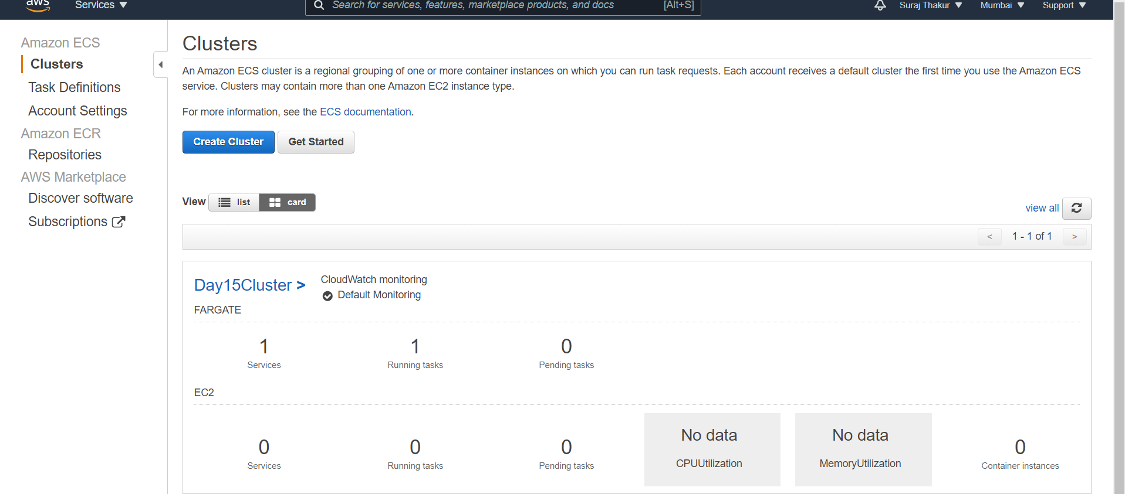

Step2: Creating container and task definition

ss2: Displaying panel with all options visible and ECS diagram

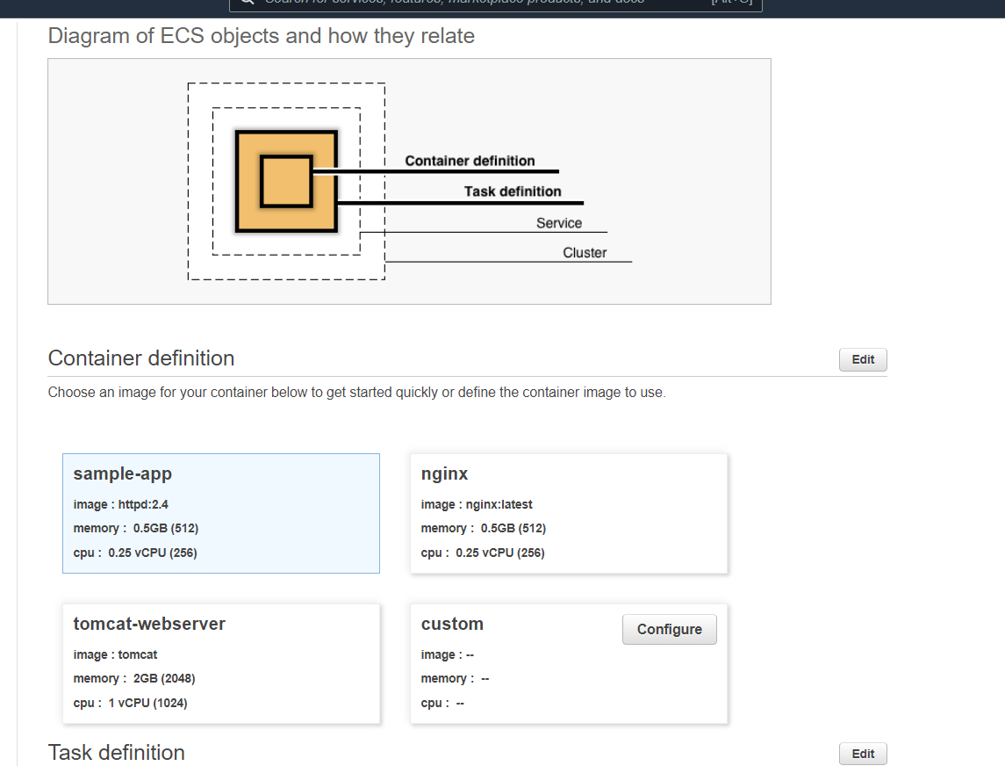

Step3: Configuring the service

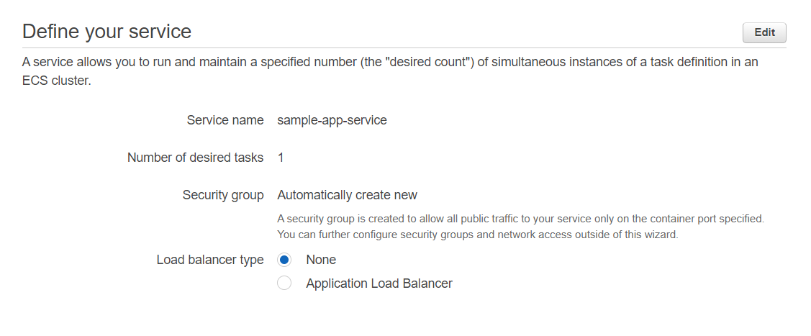

Step4: Configuring the cluster

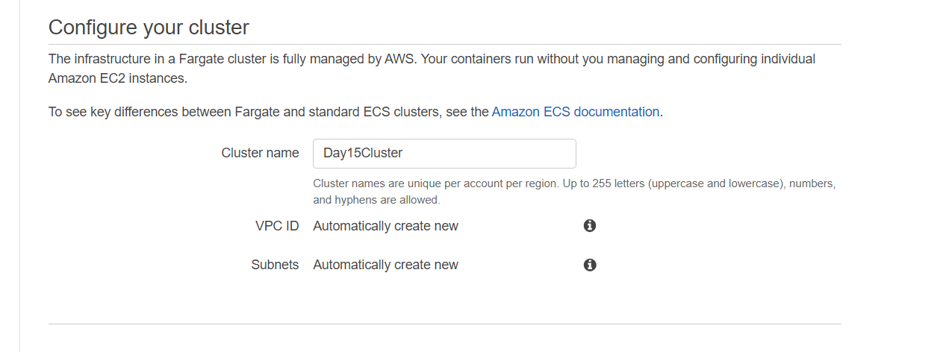

Step5: Viewing the services under the cluster

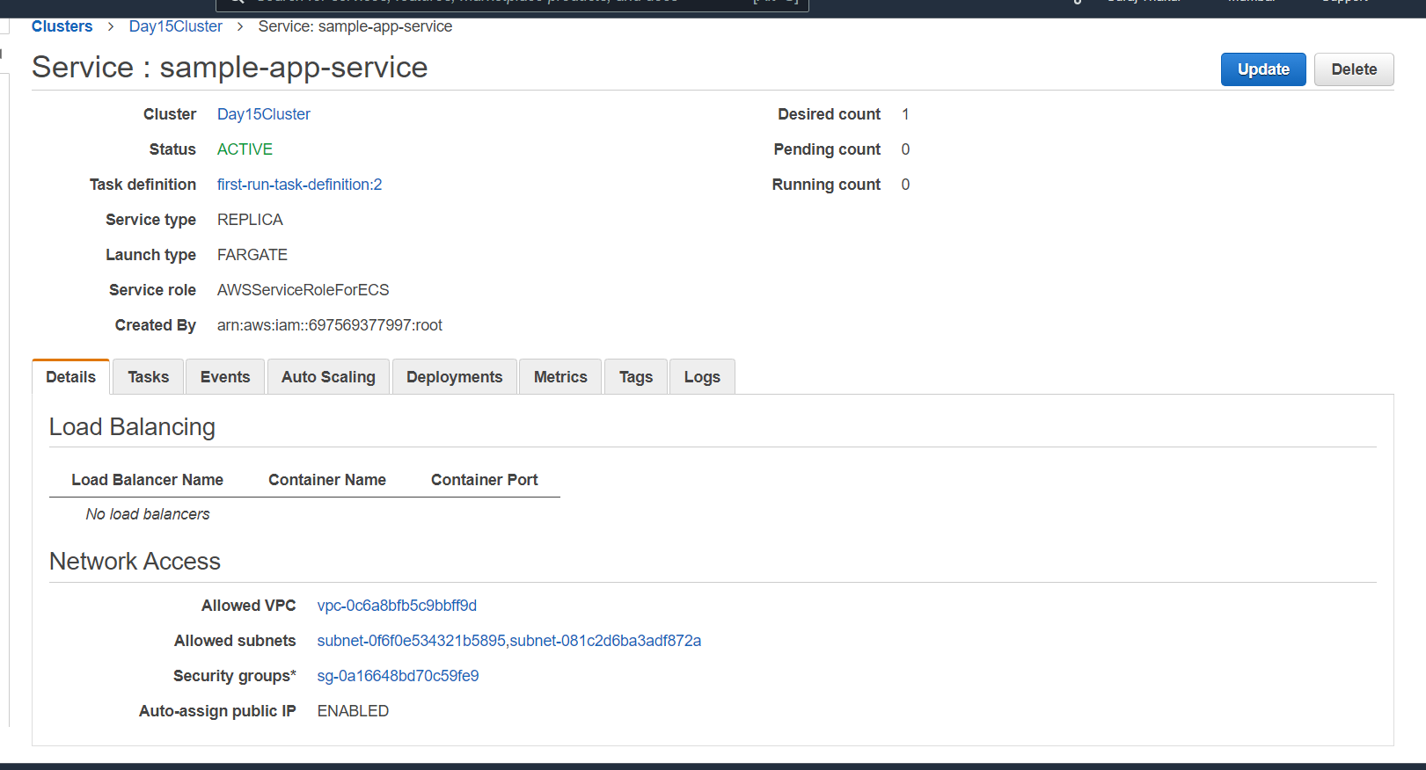

•Panel of cluster showing the ENI ID

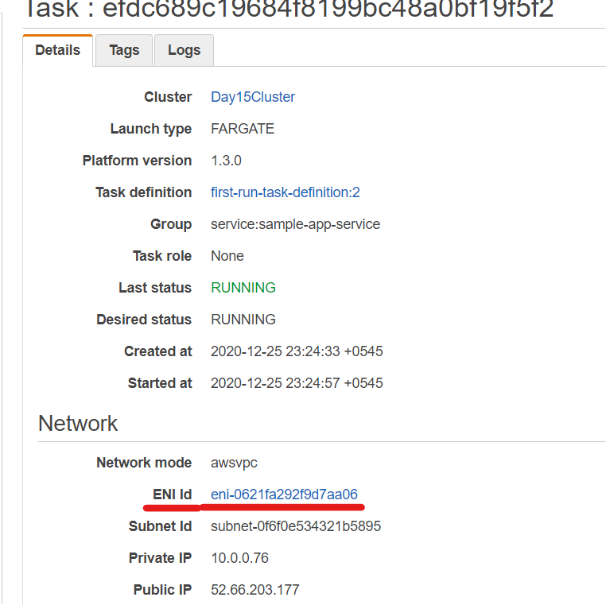

• Panel displaying the Private, Public, and the MAC ID

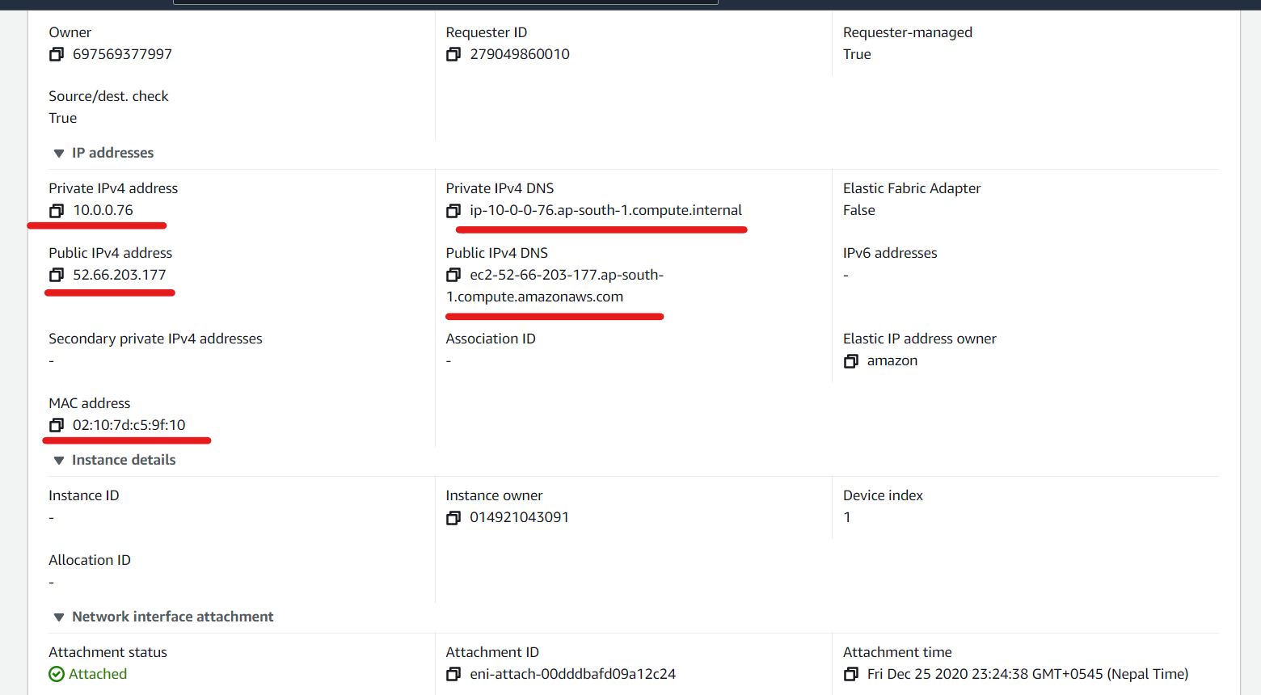

• Finally display the ECS Sample App using the public IP address of the